Assessment Report

Introduction

This project is for a software company “TNK Technologies LTD” and the task to develop tech blogging website for a fresh start up client. On this project I will be creating the website using the programming languages: HTML, CSS and JavaScript in the Visual Code software, but first I must create a Microsoft form for the client to fill out so I understand what the client desires their website to be like, I will also have to create a logo for them.

Web technologies

To kickstart the project a Microsoft form was made to find out what the client wanted from the tech blogging site and was to be presented to them.

<https://forms.office.com/e/C49Smb72hW?origin=lprLink>

Then, a logo was made in Adobe Logo maker and the main theme colour being blue was because in the world of technology. 61% of technology companies use blue as the primary colour in their brand palette. (Minton, 2021). To plan How the website will be layed out. Milanote, a designing and planning tool was used to structure how the website will be displayed.

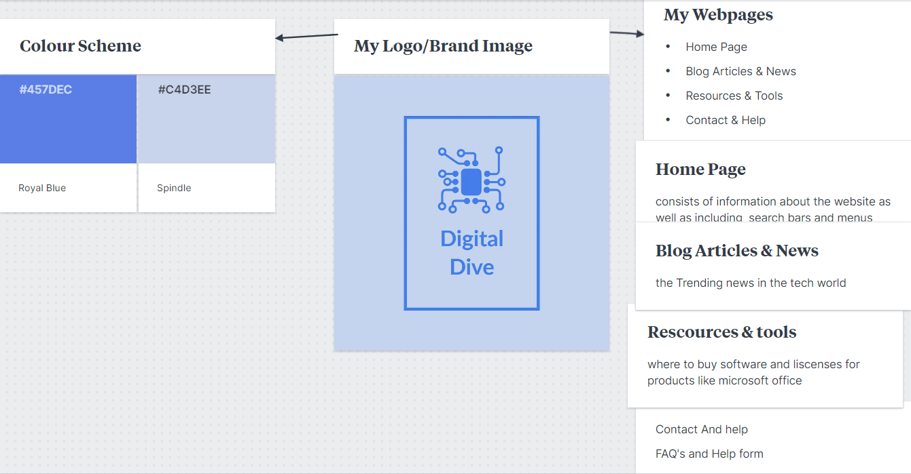

I used responsive web design as it keeps a seamless design across multiple devices such as mobile desktop tablet view. It also has a much-improved user experience. For example, Users don’t need to pinch or zoom on mobile to read content, leading to higher customer satisfaction.it is also easily adaptable for future devices that may have smaller or larger screens. To achieve this, Visual studio was used to write the code in the programming languages: HTML, CSS & JavaScript.

Multiple webpages allow the website to categorise and segment pieces of information.

Making it easier for the client to navigate and find information there looking for. It also increases engagement for the website and users are navigating through various pages and exploring various aspects of content and services, increasing time spent on the site.

It also, makes the business more scalable, as the website develops, having a multi-page structure can make it easier to expand and add content without making the site seemed cluttered. To do this a “navbar” was created in html that would have the title of each webpage and would have a link attached to it, when pressed it would take the user to the desired webpage.

Implementing e-commerce functionality can be greatly beneficial for the website as it can expand customer base from a small audience to a global audience. It also can boost revenue as you are offering services or products online it also may be easier for customers to online shop from the comfort of their homes or who might not have easy access to physical stores. Also, online ecommerce runs 24/7. To accomplish this java script was used to create a shopping cart where users could buy tech software like Adobe and Microsoft Office and add it to their basket.

Implementing form validation is also key as it helps the user avoid mistakes and makes sure accurate data is entered to ensure data integrity it also can help gain user trust as it guides the user through submission and can prevent security breaches. Furthermore, it helps prevent spam submissions. To implement this java script was used again to require data to be inputted into the form before it could be submitted for example a legitimate email.

Accessibility

|  |  |  |  |  |
| --- | --- | --- | --- | --- |
| Test number | Test name | Does it work | Evidence | Comments |
| 1 | Does the link work to  The blog page | yes |  | n/a |
| 2 | Does the link work to  The resource page | yes |  | n/a |
| 3 | Does the link work to  The contact page | yes |  | n/a |
| 4 | Does the link work to  The home page | yes |  | n/a |
| 5 | Does the form page  Check all fields are valid | yes |  | n/a |

My website

Here I will display screenshots of my website and the code for each website and explain what is happening.

Homepage:

Here is the opening page to my tech bloggings as you can see the webpage navigation is clearly displayed at the top with the logo displayed clearly in the webpage centre. There Is a consistent colour scheme of blue as well as content being clearly sectioned. The home page invites the user by telling them what the website is, why use it and how it was inspired to be created.

Here is the code for the webpage.

The red section shows the heading where the webpage name has been added as “Digital Dive “. It also shows where the CSS was added however it will need to be improved as it hasn’t worked properly. The purple section shows the navbar and which webpage it will take you if the link is pressed. Finally, the white section shows the layout of the section and colours and fonts used for each section such as the About us & Our story section.CSS was used to achieve these brilliant colours.

Blog articles and news

As you can see below is the next webpage which is where users can read the latest tech news

As you can see this week’ s “trending topic” was AI and It includes a well written article detailing AI. Once again, a consistent amount of blue shade was used because of CSS and the nav br. Is still at the top of the page as well as the logo.

Here Is the code for the webpage below. As you can see in the yellow section is where the header is, and the webpage is named “Blog articles & News”. CSS has also been attached.

In the blue section is the navbar again to move across different webpages. Finally, the white section shows the layout of the section and colours and fonts used for each section such understanding AI and How does AI work. CSS was used to achieve these brilliant colours.

Resources & Tools

Below is the net. Webpage which is where customers can access “Digital Dive marketplace” this is where users can buy tech products like software such as antivirus like MacAfee, creative tools like adobe, and productivity licences like Microsoft 365 as you can see the layout is simple and easy to understand and products and prices are clearly labelled.

Below is the code for the Resources & Tools:

The green section is where the heading is where the webpage has been named “Resources & tools” as well as the CSS. The orange section contains the navbar for easy avigation between webpages. Finally, the white section contains the text of each section and the CSS for the colours of the webpage where the consistent blue theme has been continued.

Contact & Help

Below is the webpage for the contact and help page this is where ussers can find FAQ’S and get in contact if they have any ideas for the websitte or questions as you can see the form is well presented with clear buttons and faq’s are structured easily as well as the nav bar

Below is the code for the contact & help webpage. The blue section shows the CSS file linked as well as the heading title “Contact & Help”. The pink section shows the navbar and the links to other websites. The yellow sections show CSS to achieve the blue text theme as well as the text structure. Finally the green shows java script is used to create the form, validation is used to ensure the correct data in entered as well. Also, the footer is added at the end.

CSS file

Below is the CSS fie which was to be implemented across each webpage to ensure the logo stays and takes up the background space and text positioning stays consistent.

Deployment

Requirements engineering

Using Microsoft form to find out what the client wanted the website tomdo was very useful as it was quick and easy to set up and just as quick and simple to complete

Here is the form the client was supposed to fill out as you can see it is very user friendly and has simple questions that can help build the website to detail.

Conclusion

in conclusion, from what I have learnt I will implement as a front end developer my skills of HTML to crest advanced websites with seamless and easy navigation as well as keeping data secure with validation in forms with javascript and user friendly features such as consistent colour and images with Css

Bibliography:

Minton, A. (2021) *Blue isn’t the only colour in technology*, *Razor*. Available at: <https://www.razor.co.uk/insights/blue-isn-t-the-only-colour-in-technology> (Accessed: 25 October 2023).